# Week 13 Practical

# Duties of a DBA

## Examine each of these carefully, screen captures and notes can be used as proof of completion. Perform any additional setup as required to complete these tasks.

* Check the previous night’s SQL Server database and transaction log backups and SQL Server Agent jobs for errors.
* Automate a daily backup schedule (Full and Differential)

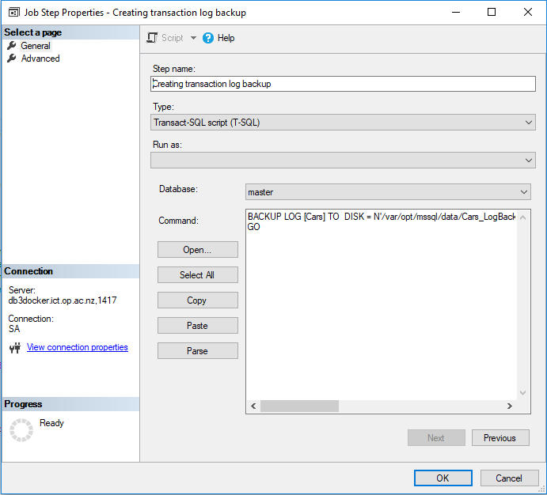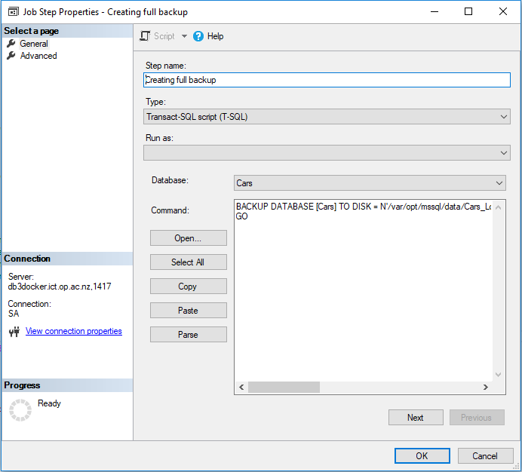

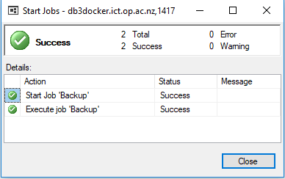

* Check all databases to make sure all are up and not marked as suspect. Check previous DBCC CHECKDB for errors.

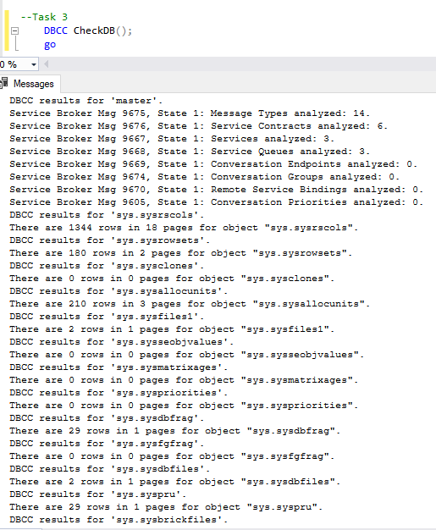

* Check SQL Server Log File entries for warnings and errors and determine if any entries warrant further investigation. Export and save the current log file.

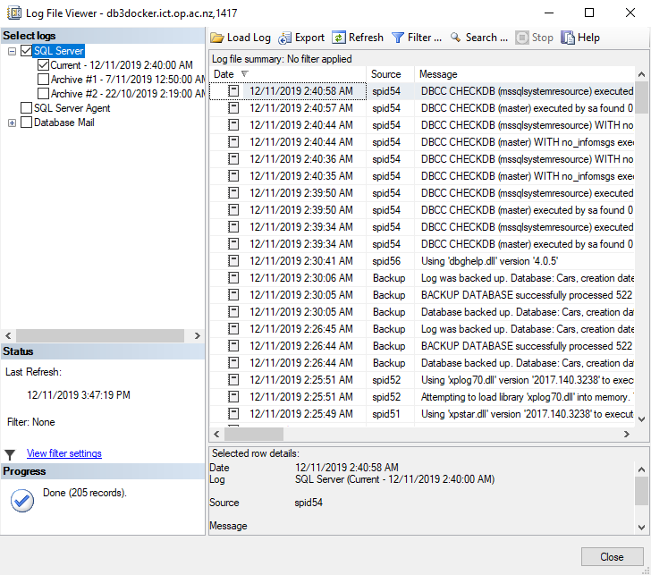

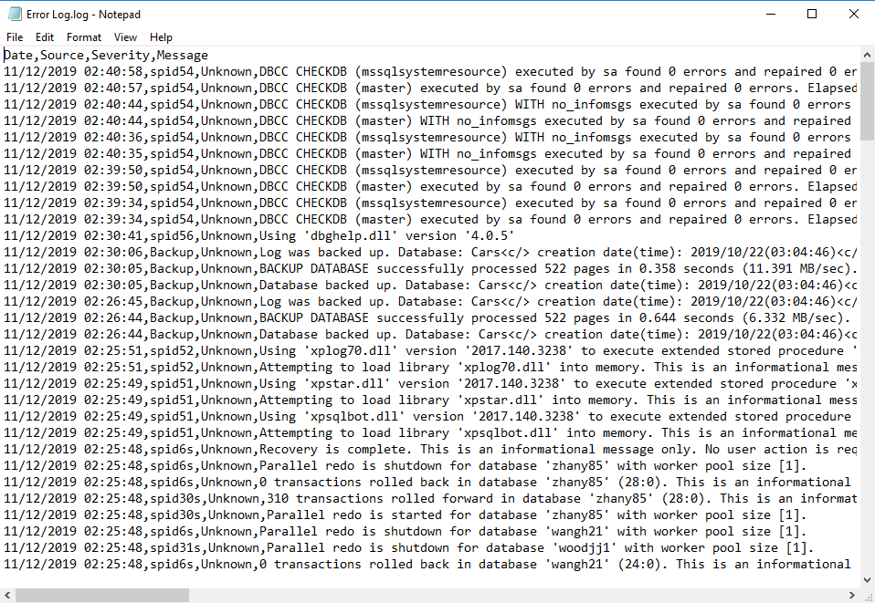

* 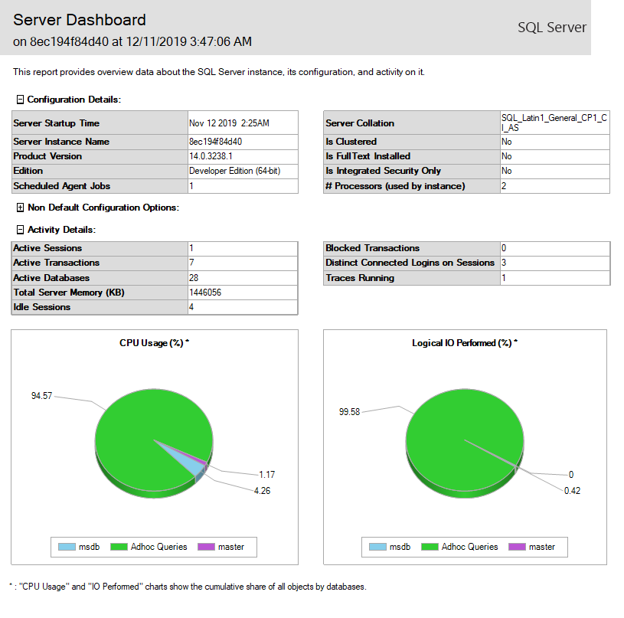Look for any security policy violations. Look for resources on the server, such as file sizes and disk space, and audit growth for long-term projections.
* Explore using long-running queries or tasks, Perform, etc. to generate data. Set up a sensible logging report to monitor disk and memory usage.

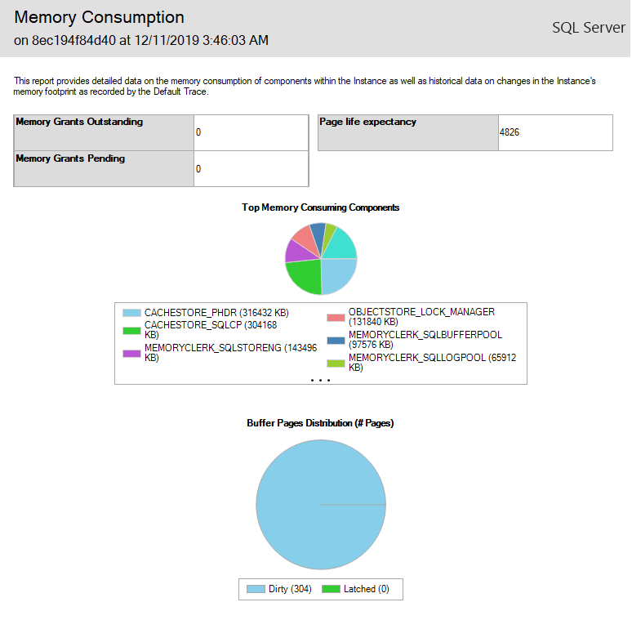

* What about you’re Container? What sort of usage data can you extract?

### Use your pubs database

You want to recover a single table from a database backup – why?

It is the only table effected by a recent data loss. Restoring an entire backup can take a significant amount of time, and you are under a lot of pressure to get it done fast

Perform the necessary data adjustments to check your solution is correct (delete rows etc.). Provide a script for each of the following scenarios:

Creating a new database that will house the restore

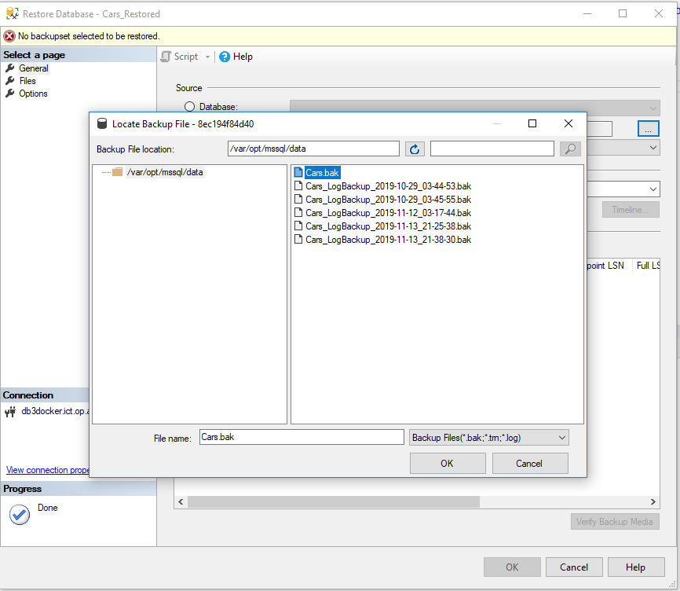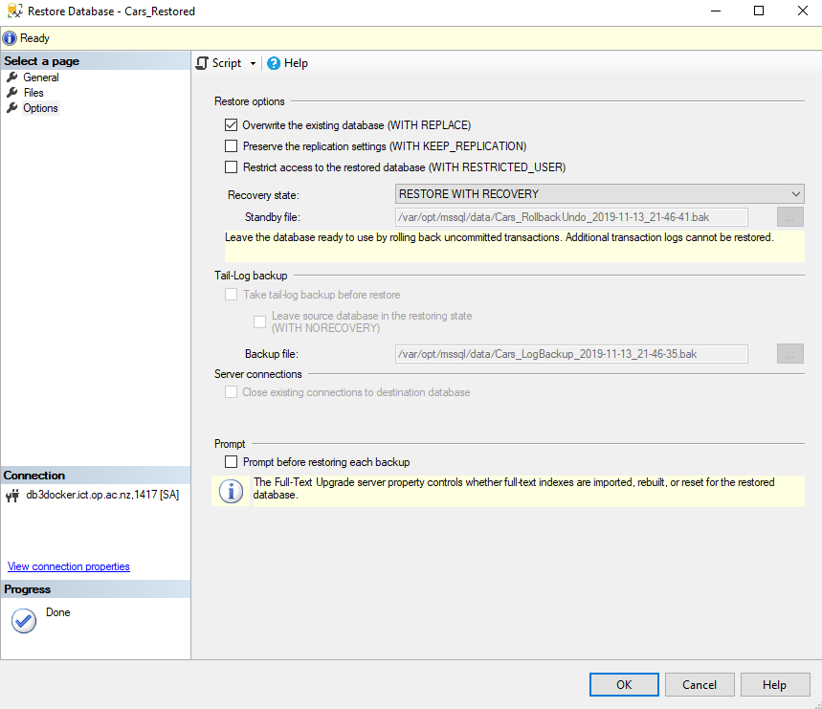

1. The table still exists, but only some rows were deleted, restore the deleted data only.
2. The table has been too badly damaged; restore the table structure and all the data.